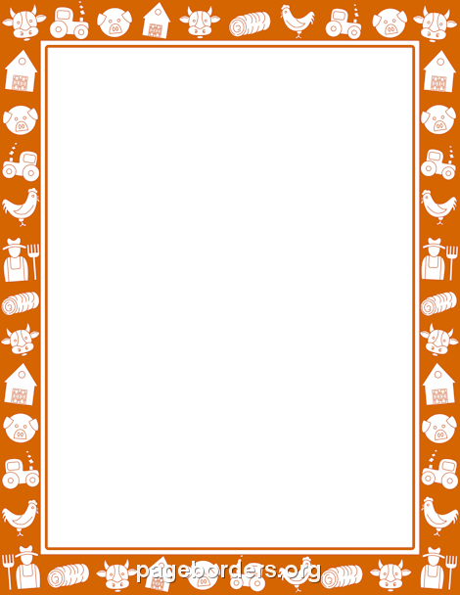

**Half Term Overview**

**Our topic for this half term is ‘Farms’. We will also be learning about the following festivals: Pancake Day, Lent, St David’s Day, St Patrick’s Day, Holi and Mother’s Day.**

**The pre-school children will continue to be introduced to a new letter sound each week. Please support your child in finding an object at home that begins with that sound to bring for show and tell on Wednesday mornings. A text will be sent to inform you of the sound for each week.**

**The reception children will receive another home learning challenge at the beginning of this term which should be returned by the last week of half term (text message reminders will be sent out).**

**The children will have PE with Miss Johnston on a Monday afternoon and Mr Green on a Thursday afternoon. The children’s PE kits (including trainers/plimsolls) should be kept in school throughout the week.**

**Our Share a Book morning this half term will be on Wednesday 25th March. We hope that you will be able to join us.**

**Many thanks,**

**All of the EYFS staff.**