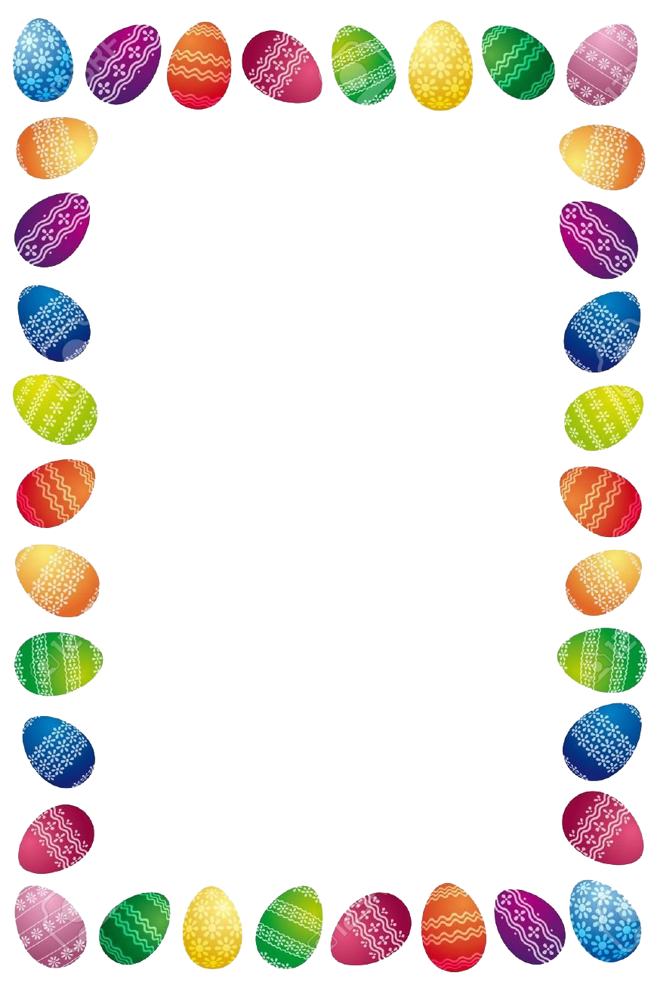

Dear Parents,

Next Wednesday, children in Class 2 will take part in an ‘Easter Extravaganza’. This will take part in individual classes.

Your child will have fun taking part in a range of activities including a chocolate egg hunt, egg decorating and the annual ‘egg dump’ if they wish.

In school, children will decorate one of their eggs as their favourite animal or character from a nursery rhyme, story or film or as a famous sportsperson or superhero – these are just a few ideas to get you started! If your child wants to paint a base colour onto their egg, this might be a good idea to do at home so that it can dry.

If children have any useful resources at home which they think they would like to use in their designs, please can they bring these in to school **next Wednesday** with **2 hard-boiled eggs**, one to decorate and another one for the ‘egg dump’. They are welcome to bring in more hard-boiled eggs, just in case their egg ‘eggsplodes’! A wide range of craft supplies will be available in school for children to use.

If you have any questions, please feel free to ask any member of the Class 2 team.

Many thanks,

Mrs Billington